Name:_________________________

**Using the Radio to Send a Message - MakeCode**

**What you need:**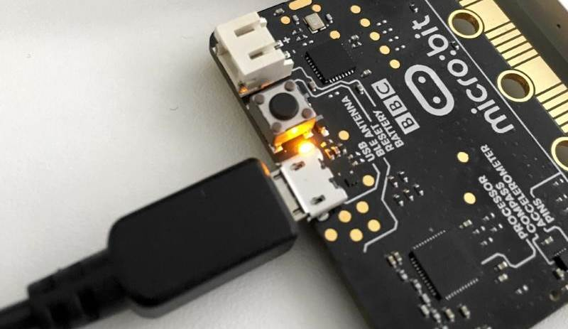

1. A computer with a USB port
2. V2.0 micro:bit
3. USB cable
4. A partner with a V2.0 micro:bit

**Setup:**

1. Plug in your micro:bit with the USB cable. The small USB mircoB end goes to the micro:bit and the regular USB end goes to the computer.
2. In a browser, go to <https://makecode.microbit.org/>. This is where you will program your micro:bit.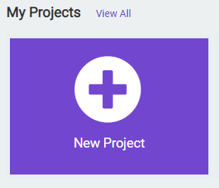
3. Click on ‘New Project’
4. You can name your project whatever you want, but you should name it based on the title of the lab. In this case, ‘Radio Messaging’

**Instructions:**

1. Inside the **on start** code block, we need to set the **radio group** value. This value makes sure that communication over radio only takes place between you and your partner. You both need to choose the same value and make sure another group isn’t using the same value. To do this, drag the **radio set group** code block from the **Radio** tab. Set the value to your choice of group number (between 0 and 255). In this case, the default value of 1 is used.

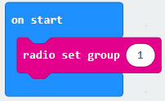



1. Inside the **forever** code block, we will use the two **if** blocks from the **Logic** tab. This code block will execute whatever code is inside it when the statement we give it becomes true.

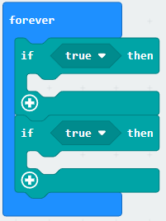

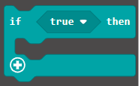

1. Inside the **if** code block, we need to change the condition of when the if statement becomes true. We will change it to when the micro:bit detects when button A or B are pressed. Drag the **button pressed** logic block from the **Input** tab, inside of the **if** code block where it currently says **true.** Repeat for the other button and change the drop down to say button **B.**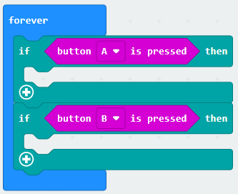



1. To have the micro:bitsend messages, we will use the **radio send string** code block found in the **Radio** tab. Drag this block to the first **if** block that is made true when button **A** is pressed. You can change what the message says in the text field for that code block.

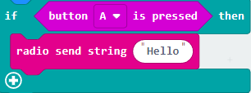



1. To receive a message from your partner's micro:bit, we will use the **on radio received** code block that has the **receivedString** field. This code block will operate outside of the **on start** and **forever** code blocks.

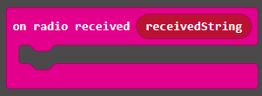

1. Drag the **show string** code block from the **Basic** tab inside the **on radio received** block. Then, click and drag on the **receivedString** field on the on radio received block to the text field on the show string block. This will allow the message your partner sends to be displayed on the LED screen.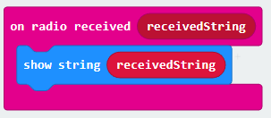



1. Click the **Download** button on the bottom on the bottom left hand side of the screen. This will upload your program to the micro:bit. When you press button **A**, does your partner see your message? When your partner presses their button **A,** do you see their message?

**You Try It!**

Can you send a message to more than just one person? Three? Four?